**Accounting Quiz 2**

**Dr. Sarfaraz Bhutto**

1. **paper**

**A. MAKE A TRIAL BALANCE OF THE BELOW BALANCES**.

Service Revenue =7900

Cash =7150

Accounts Receivable =6000

Supplies =2000

Prepaid Insurance=3000

Office Equipment=15000

Accounts Payable=4500

Unearned Service Revenue=4000

T. Masasi, Capital =217

Salaries Expense =4000

B.

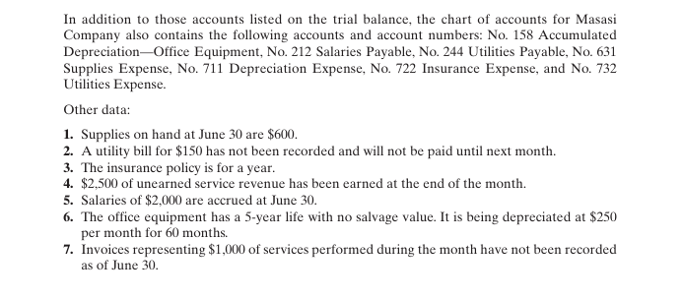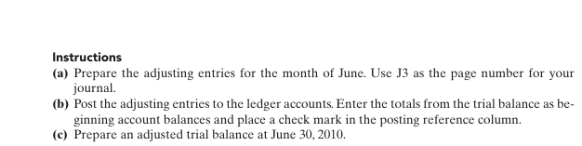

Solutions

**UNADJUSTED TRIAL BALANCE**

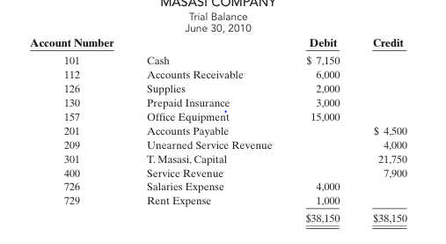

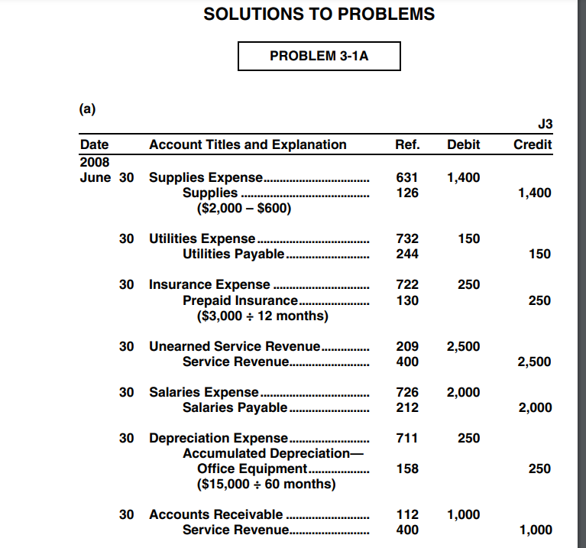

**LEDGERS**

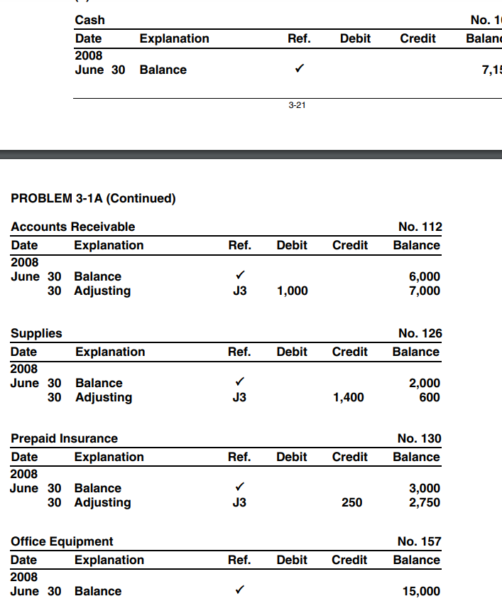

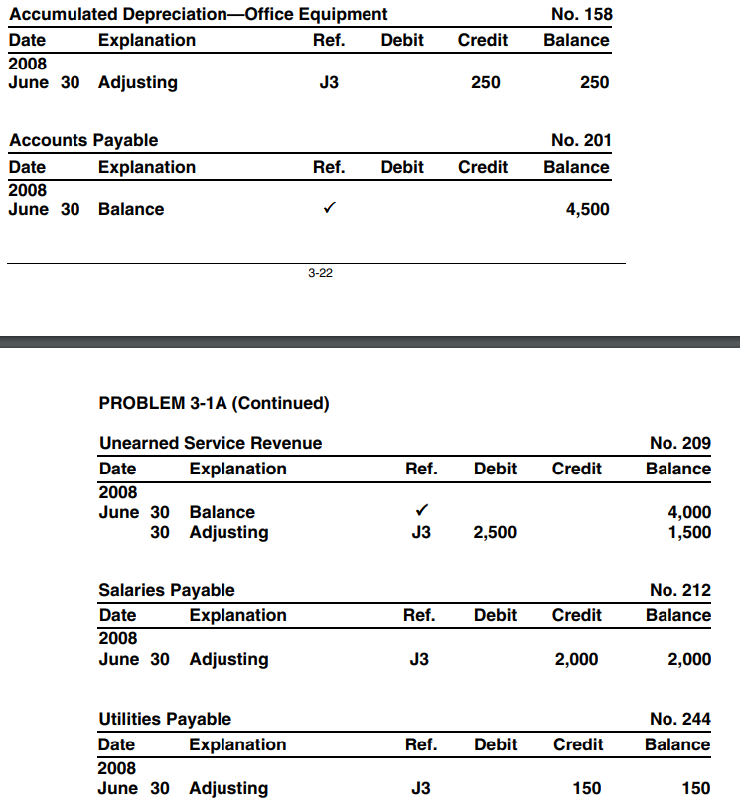

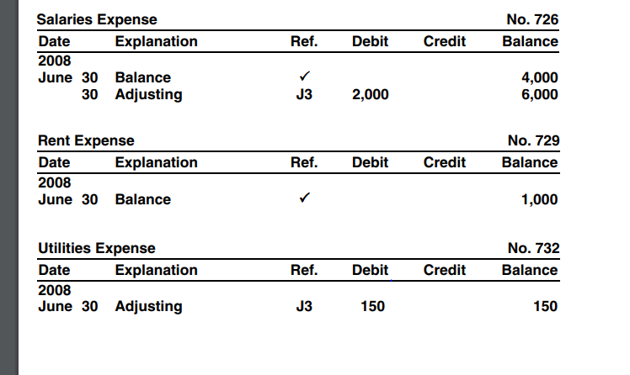

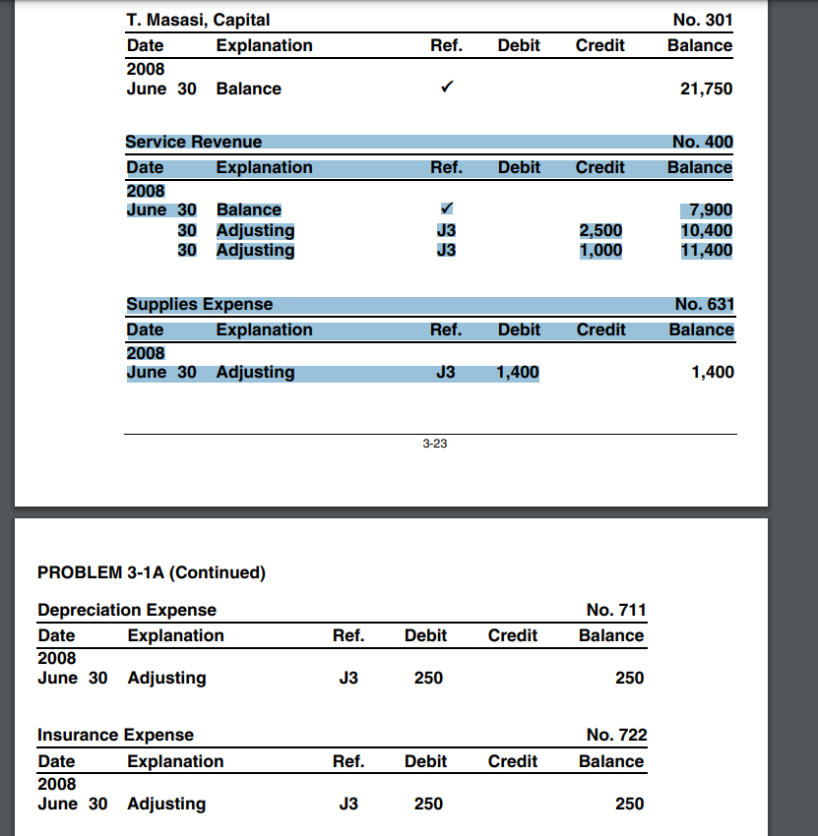

**ADJUSTED TRIAL BALANCE**

